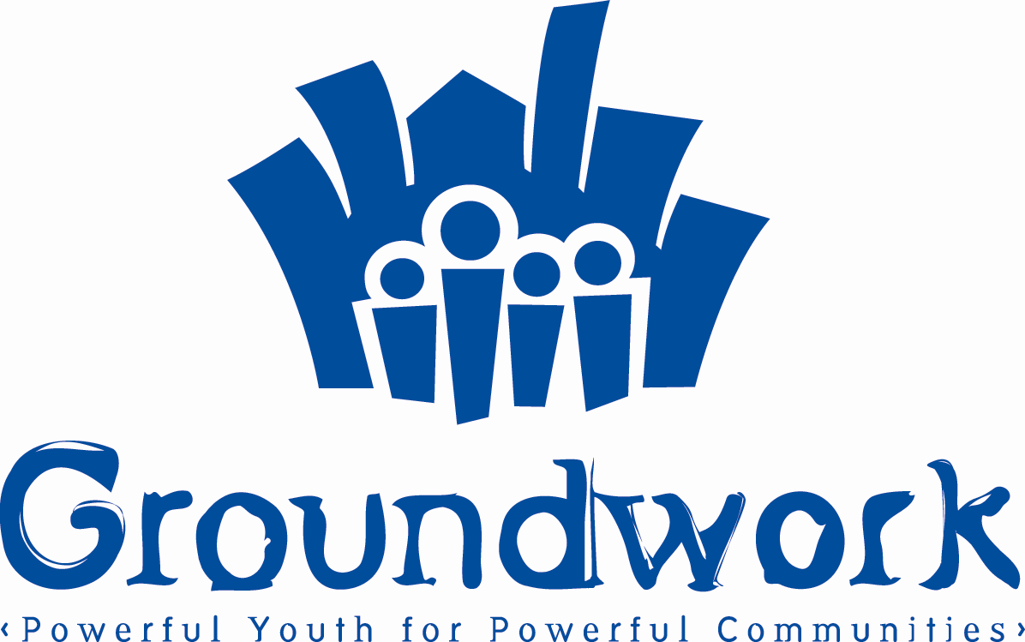

For Immediate Distribution

CONTACT
Monte Givhan
Groundwork Inc.
718 346-2200 x 108
mgivhan@groundworkinc.org

Richard Buery to be honored by Rush Philanthropies.
Social entrepreneur working to improve lives of children and families in the neighborhood he grew up in.

Brooklyn, NY (April 9, 2007). Rush Philanthropic Arts Foundation, the charitable foundation started by hip hop and fashion mogul Russell Simmons and his brother Danny Simmons, will honor Richard Buery, Co-founder and Executive Director of Groundwork, Inc. in a ceremony at One Time Warner Center next month. The ceremony will be held on Wednesday April 11 at 7:00 pm. The event coincides with the opening of the Rush East New York Arts Center.

Buery, an East New York native, co-founded Groundwork in 2002. A graduate of Harvard College and Yale Law School with a background in youth development and social entrepreneurship, Buery was convinced that the best way to empower his community was through empowering its youth, hence Groundwork’s slogan: “Powerful Youth for Powerful Communities.”

“Young people in East New York face a dizzying array of obstacles to personal achievement, including inadequate educational opportunities, a dangerous physical environment, the absence of stable adult mentors, and a lack of critical developmental experiences due to the community's physical and cultural isolation,” says Buery.

As a long-time East New York public school teacher, Buery’s mother was able to navigate the educational system and get Buery and his sister into good public school programs and involve them in quality out-of-school experiences. But too few East New York families have access to the information and institutions from which Buery benefited.

The award from Rush Philanthropic holds a special significance to Buery, because Rush’s work addresses a need frequently identified by the children and families Groundwork serves.

“Groundwork seeks to develop the network of services, experiences, and structures that wealthier communities take for granted,” says Buery. “In creating the Rush East New York Arts Center, Rush Philanthropic has created an institution that will address a major need in East New York and provide children and families with an outlet for creative expression and arts education.”
The Rush East New York Arts Center, located at 2588-90 Atlantic Avenue, is housed an 11,000 square-foot building that was donated by Ron Hershco of United Homes.
“We are ecstatic about the Center opening in East New York,” says Buery, “and I personally look forward to other foundations and companies following suit by investing in the children and the families in this community.”
For more information about Groundwork, Inc. visit www.groundworkinc.org.

